Bike Sales Report

**Prepared by:** [Sebastian Ramirez Orozco]

**Date:** [5/25/2024]

**Prepared for:** [Recruiters and Hiring Managers]

## Report Summary

The scope of the project is to perform a basic data analysis on the company bike sales and answer business queries. Through this analysis we gain important insights such as:

* Top sales by age bracket: Middle-Aged Adults.
* Bottom sales by age bracket: Old Adult.
* Top customers by commute distance: 0 to 1 mile.

Also, important steps to follow based on our analysis are:

* Defined more useful KPI’s and how to capture this information.
* Develop a better plan of action to generate better business queries.

## Introduction

Did you know that riding a bike can help you save up to $1,200 a year on a gym membership?

To put it in perspective, an average gym membership in the US costs between $30 and $100 a month. Also, are you aware the yearly cost of maintenance for a bicycle is 20 times cheaper than for a single car? You should own a bike!

Now that you know bikes are good for you and your economy, let’s proceed with our analysis on bike sales. The [Bike Sales Dataset](https://github.com/AlexTheAnalyst/Excel-Tutorial/blob/main/Excel%20Project%20Dataset.xlsx) was provided by Alex The Analyst through his GitHub profile. The data set covers a single table called bike buyers, 14 columns and 1001 rows. It was undertaken as a practice and guided project to familiarize myself with simple data analysis and reporting.

Our main objective is to answer the following business questions:

1. What age bracket is the one with the most sales?
2. What age bracket is the one with the least sales?
3. What is the average income by gender of people who buy our products?
4. Who are our top customers by Commute Distance?

Answering these questions will allow our investors and stakeholders on business decision making and what strategy to follow.

## Data analysis

Project Summary

The main goal of the project is to perform data analysis on Excel and provide an answer to stakeholder’s inquiries.

The project has the following steps:

1. Data Sources and Data Gathering
2. Assessing and Data Cleaning
3. Data Analysis
4. Data Visualization

Project Environment

This project is run entirely through Excel. All calculations, cleaning and visualization are going to be perform using Excel and/or Power Query. Dataset must be downloaded from GitHub and open in Excel.

Step 1. Data Sources and Data Gathering

**Data Sources**

* Bike Sales Dataset (GitHub).

**Data Gathering**

The dataset was obtained from GitHub. It includes bike buyer’s sheets.

Step 2. Assessing and Data Cleaning

**Importing Data**

Data is just open through the Excel File.

**Removing Duplicates**

Using the Remove Duplicates from the Data tab will allow us to remove duplicated data from our table, which will delete 26 duplicates.

**Convert To Table**

We are converting as a table to allow us to work with pivot tables and pivot charts later, also we change its name to Bike Sales.

**Replace Values**

On the Marital Status column with Find and Replace option from the Home tab, we will replace the M for Married and the S for Single. For the Gender column M is replaced for Male and F for Female.

**Format Values**

For the Income column, we will format it to currency and reduce the decimals to none.

**Change Values**

As we can see, the Age column has a wide range of ages going from 25 to 89. Since is not usable for analysis we are changing these values to brackets using If function. If someone is younger or equal to 39 it will be Young Adults, younger or equal to 59 Middle-aged Adults and younger or equal to 99 Old Adults. For everything else will be Invalid.

For this changes we will create a new column called Age Bracket and do our If function here. After this, we copy as value the column in a new one and delete the one with que if function.



Step 3. Data Analysis

**Pivot Tables and Pivot Charts**

* A pivot table named Average Income Per Purchase will be created in a new sheet using pivot table from our Bike Sales table. We will insert the Purchased Bike column into the column value Gender into rows and Average of Income to values.

On the Value Field Setting, specifically Number Format we will delete the decimals on our numbers. Now using the table created we will insert a column chart to visualize the data and proceed to format the layout and design to make it more visual friendly.

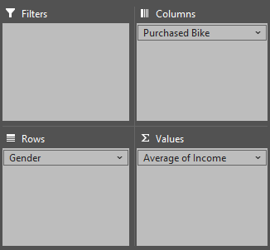

* To create our second pivot table, we will copy the Average Income Per Purchase sheet, so everything is connected and change the name to Customer Commute. On the row values we will add the Commute Distance, on values Purchase Bike will remain and Purchase Bike will also be added to columns. A Line chart is inserted and formatted according to what we want.

Note. Sorting the values on our row label in ASC or DES won’t allow us to sort it correctly, so a manual sort is necessary.

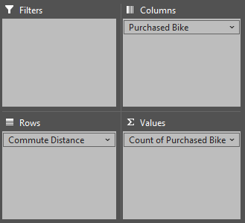

* For the last one, we will copy the Customer Commute sheet, and just change the row value to Age Bracket. The table name will be change to Customer Age Bracket and sorting the manually to row labels is necessary. As for the chart, a line chart will be used.

Additionally, using the pivot chart we will create 3 new slicers that will be for Marital Status, Region and a Education.

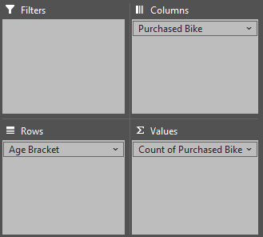

**Dashboard Creation**

For our final step we create a new sheet where our dashboard is going to be.

* For the A column we will adjust the width to 1 and the same for the row 1, where the height will be 5.
* Now we inserted a shape to define our dashboard and add a title.
* Here we will cut and paste all our charts in our dashboard and arrange them as we see fit. As a little note use ALT and drag the carts to adjust them.
* To make it cleaner we will hide the gridlines, formula bar and headlines.
* Lastly, we click on the slicers, go to the timeline tab, and report the connections to connect all our charts.

Note. You can also disable the scroll bars, sheet tabs and more.

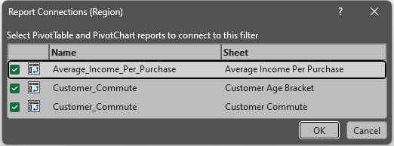

Step 4. Data Visualization

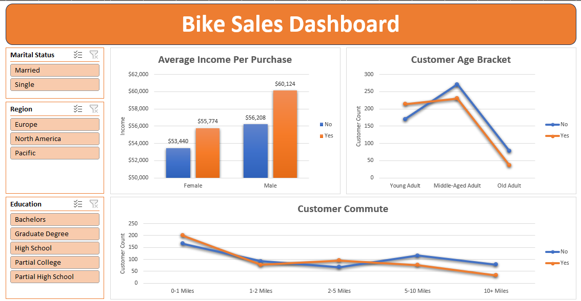

**Business Queries**

1. What age bracket is the one with the most sales?

Middle-Aged Adults are the bracket with most sales with 230 sales as shown on the highest point if the orange line.

1. What age bracket is the one with the least sales?

Old Adult buy the least bikes with only 37 sales. We can appreciate this result looking the lowest point of the orange line.

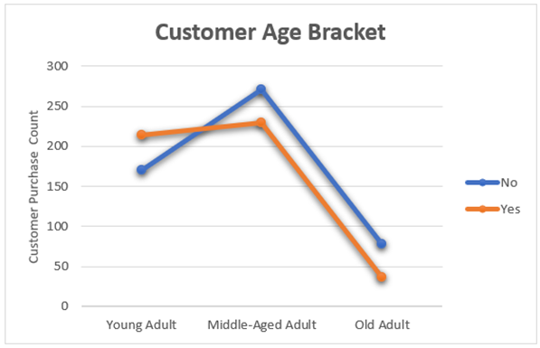

1. What is the average income by gender of people who buy our products?

The average income for Males is $58,063 and for Females is $54,581.

1. Who are our top customers by Commute Distance?

Our top customers by Commute Distance are the 0 to 1 mile as shown below.

## Recommendations

Some important recommendations:

* Is important to notice that the queries in question were not very valuable for insights and business needs, so a meeting with stakeholders and domain savvy collaborator should be made to stablish a better plan of action and generate better business queries.
* Data is lacking some important KPI’s that can provide a better understanding of how things go, a meeting between collaborators, data analyst, data engineers and decision-makers should be done to defined said KPI’s and how to capture this information.

## Conclusion

To conclude this report, I highly recommend in asking the right business questions and select the correct KPI’s for the project with our for future business strategies, objectives and goals.

Following these steps will bring a significant improvement in operation and profit in our company, so I urge all collaborators to act.

## References

* **Sources:**

<https://use.expensify.com/resource-center/guides/analytic-reports>

<https://github.com/AlexTheAnalyst/Excel-Tutorial/blob/main/Excel%20Project%20Dataset.xlsx>

<https://www.youtube.com/watch?v=opJgMj1IUrc&list=WL&index=37>

* **Tools:** Excel.
* **Acknowledgments:** To Alex the Analyst on his guided excel project.